**MIDDLETON CHENEY FOOTBALL CLUB**

**ANNUAL GENERAL MEETING**

**1965**

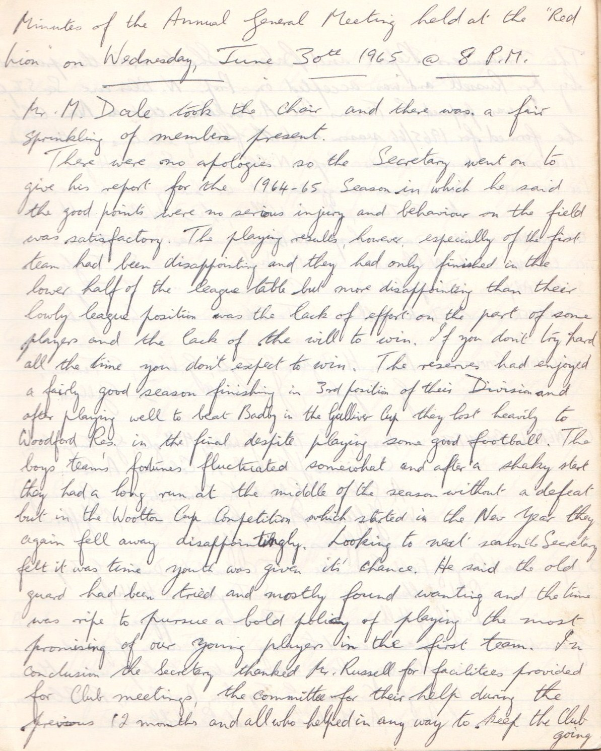

**CONTINUED**

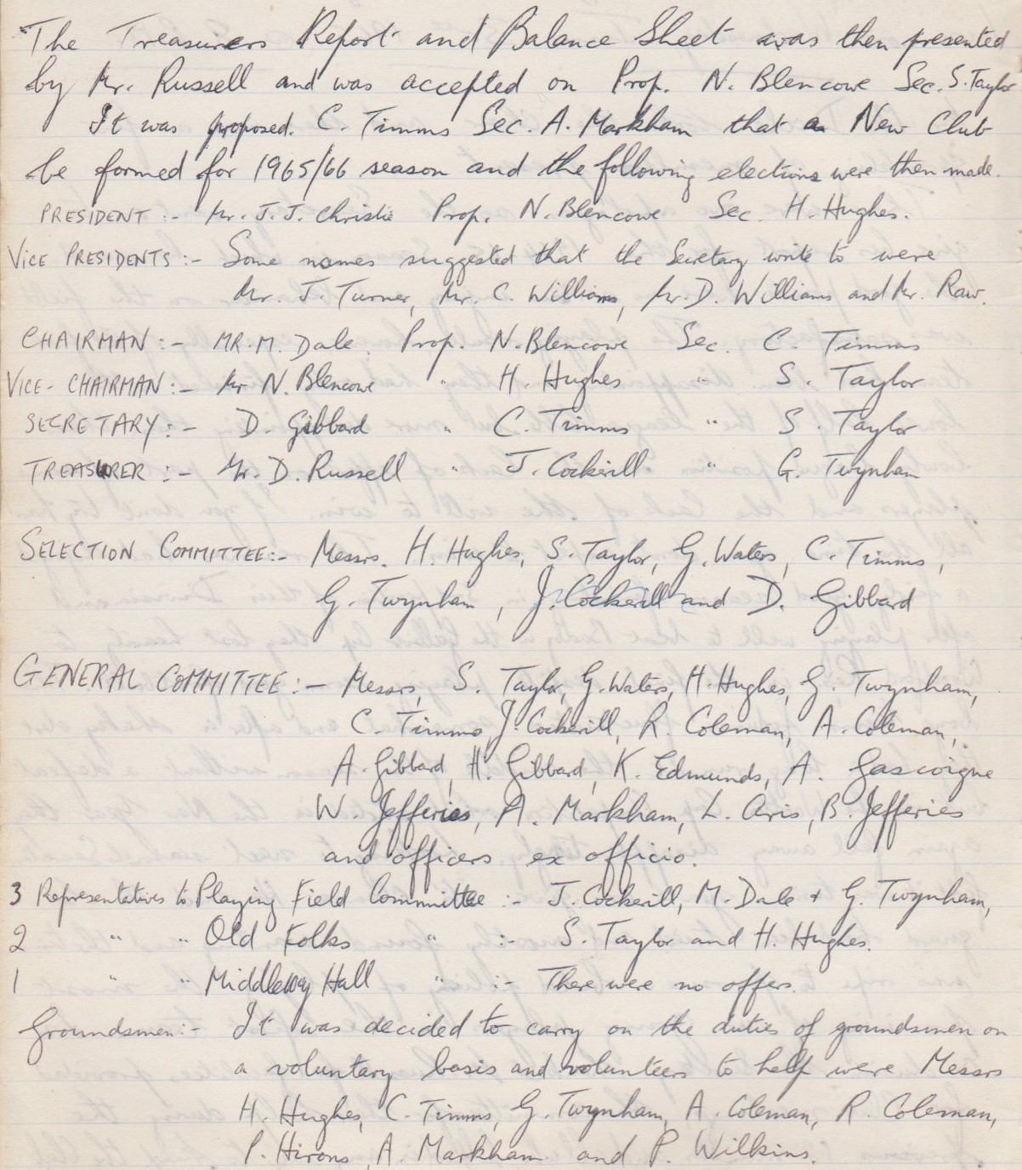

**CONTINUED**

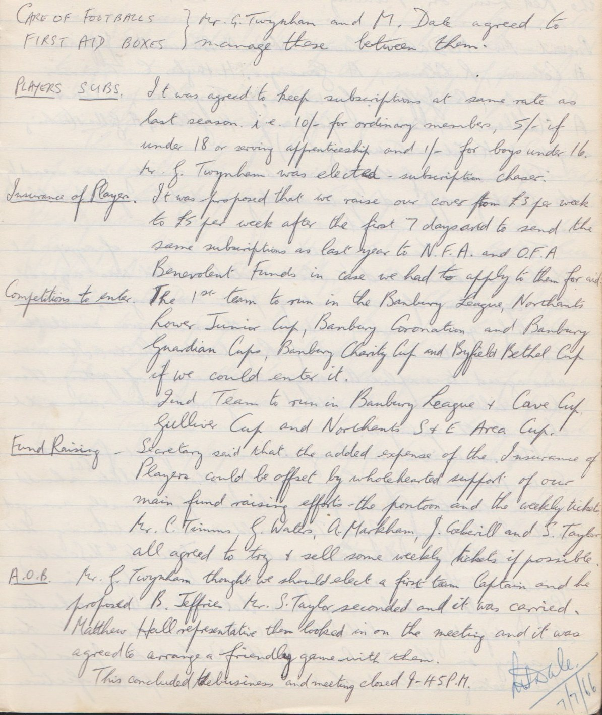

**General Meeting**

**November 8th 1965**

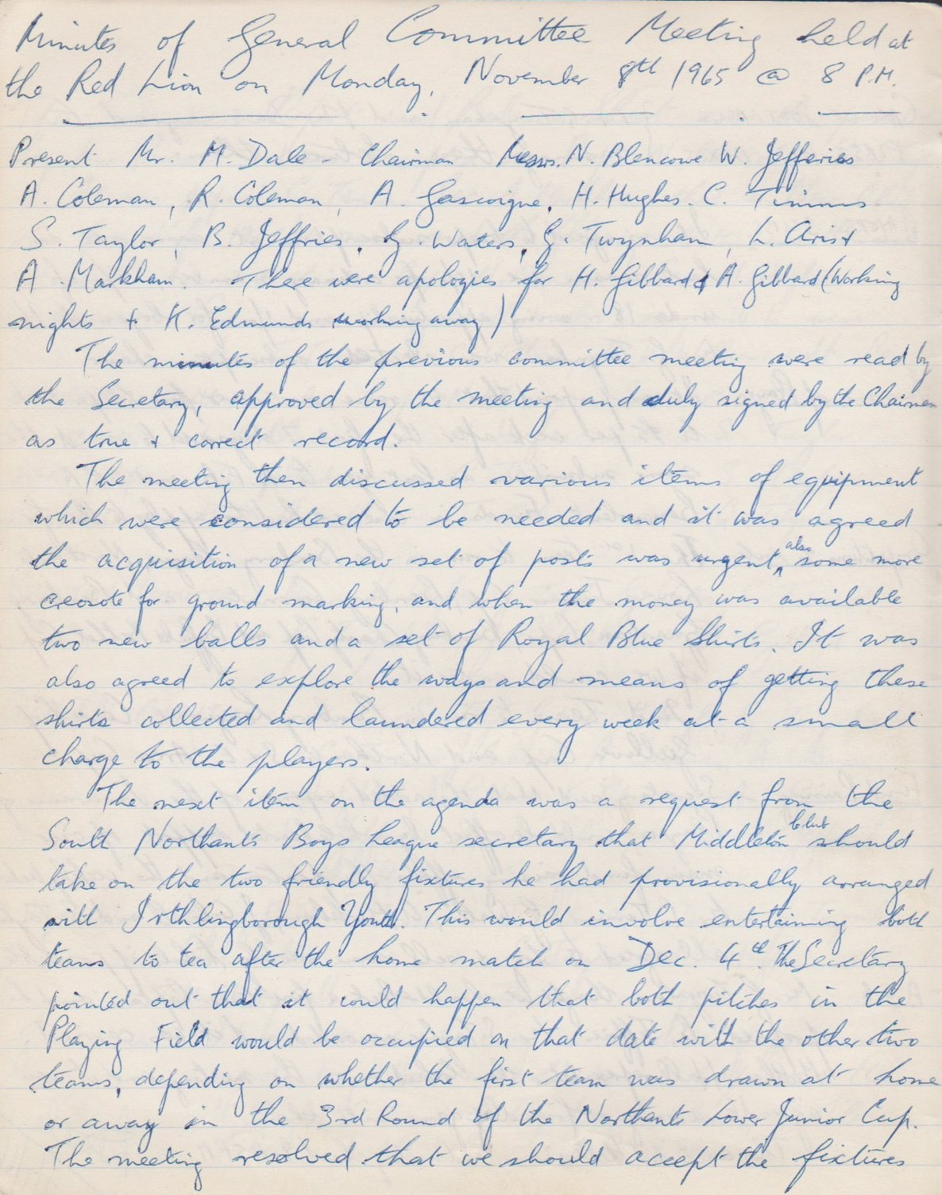

**Continued**

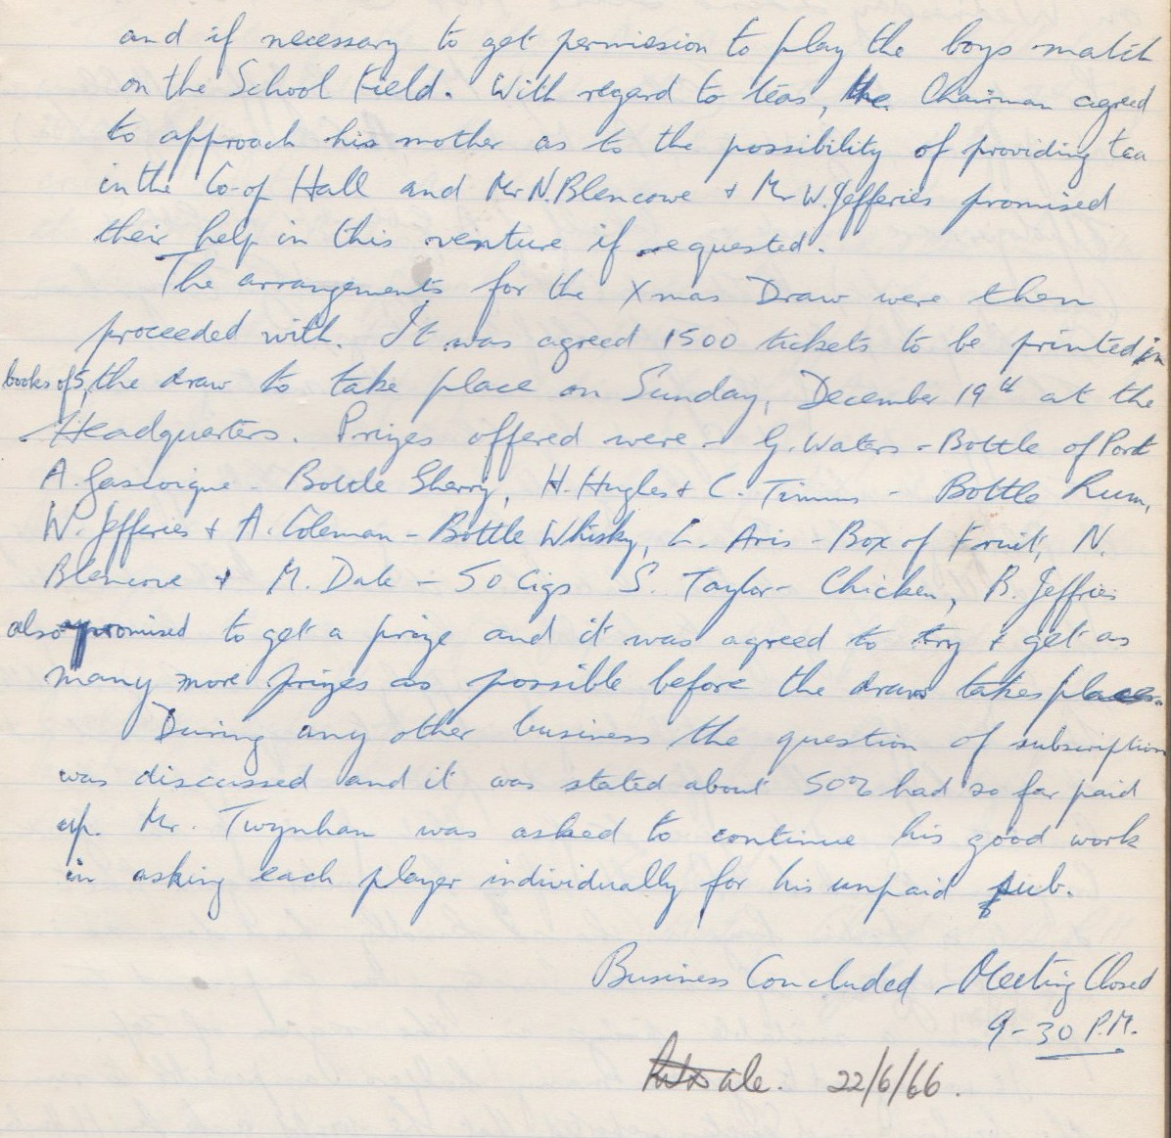

**General Meeting**

**June 22nd 1966**

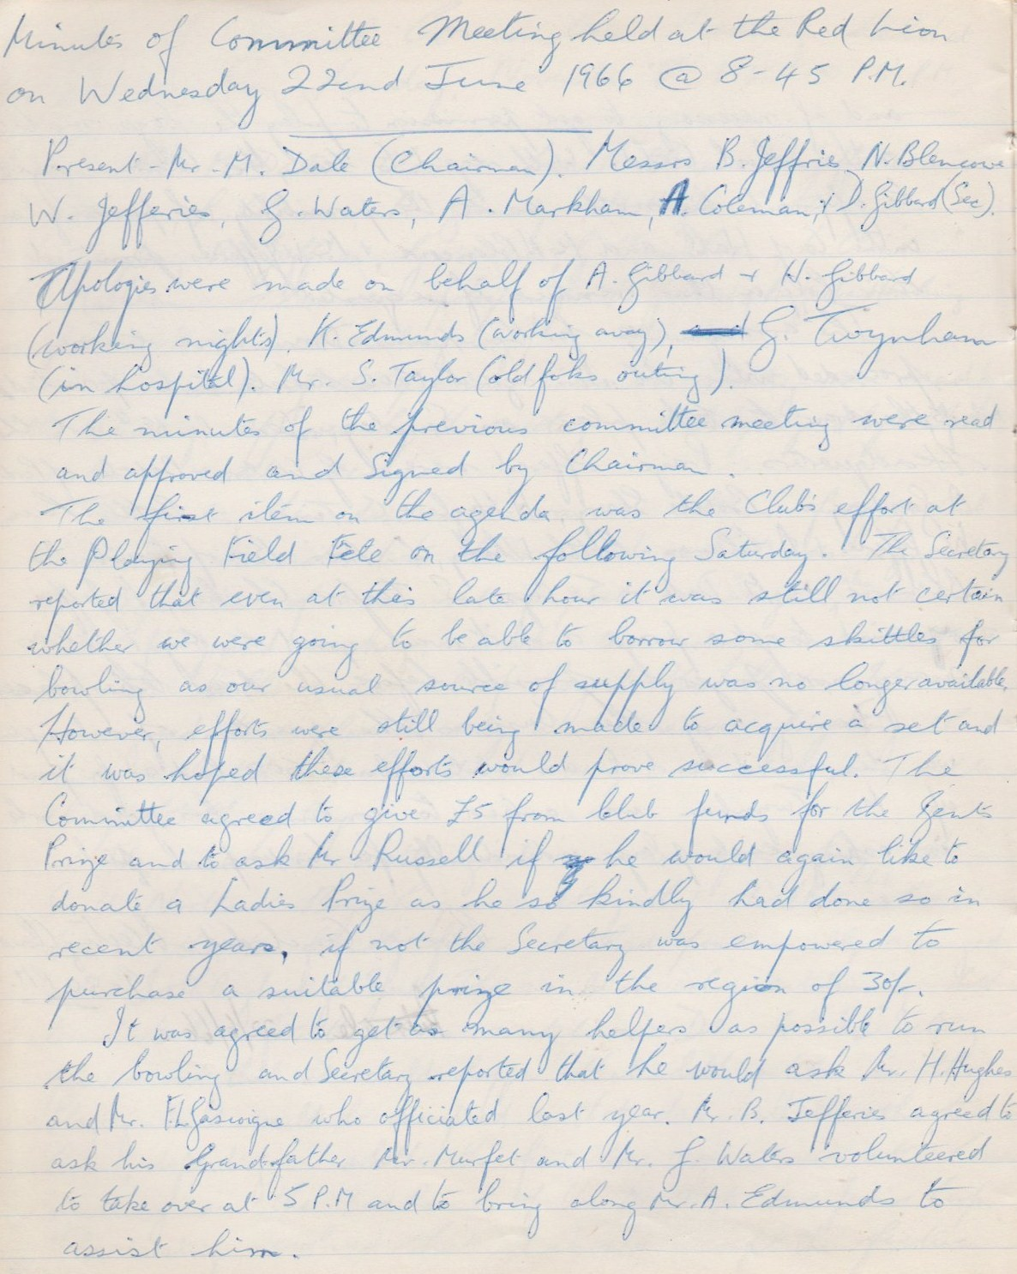

**Continued**

